|  |  |
| --- | --- |
| **D:\CE\WhatsApp Image 2021-05-08 at 4.35.03 PM.jpeg**    ***“CULTIVATING EXCELLENCE IN EVERY STUDENT”***  **‘**  **RAKESH KUMAR**  **M.Sc. (Chemistry) B.Ed.**  **CTET, PSTET, HPTET qualified**  **thakurkumar82@gmail.comA taste of technology | News Centre - Official news site of Calderdale  Councilhttp://chemistryexpert.in/** |  |
| **Class:-XII (Sci.) Name of Student……………………**  **Subject:- Chemistry**  **10 year QuStions**  **Chapter-11**  **Alcohols, Phenols & Ethers** |  |

1. 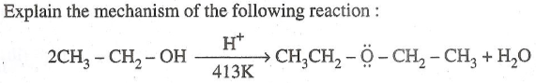
2. 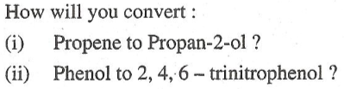
3. How do you convert the following: (i) Phenol to anisole (ii) Propan-2-ol to 2-methylpropan-2-ol (iii) Aniline to phenol
4. Give reasons for the following : (i). Phenol is more acidic than ethanol

(ii) Boiling point of ethanol is higher in Comparison to methoxy methane.

(iii) (CH3)3C-O-CH3 on reaction with HI gives CH3OH and (CH3)3C- I as the main products and not (CH3)3C-OH and CH3I.

1. Write the main product(s) in each of the following reactions :

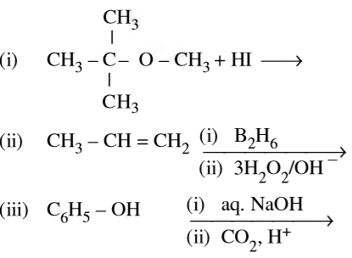

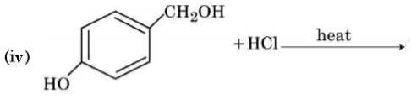

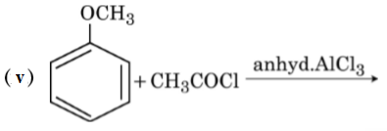

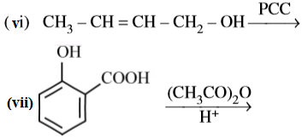

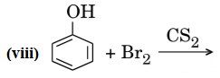

1. 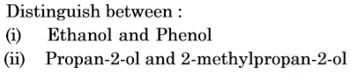
2. 

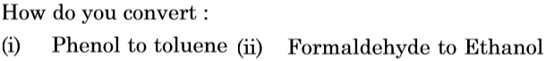

1. 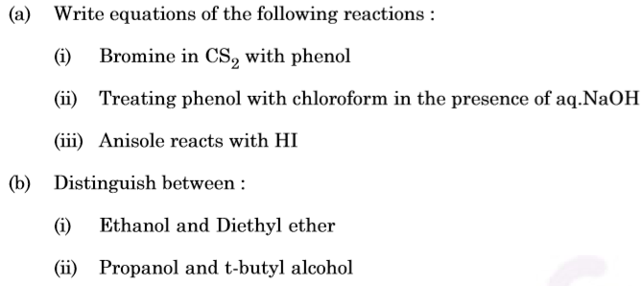 
2. (a) Give simple chemical tests to distinguish between the following pairs of compounds : (i) Ethanol and Phenol (ii) Propanol and 2-methylpropan-2-ol

(b) Write the formula of reagents used in the following reactions :

(i) Bromination of phenol to 2,4,6-tribromophenol

(ii) Hydroboration of propene and then oxidation to propanol.

(c) Arrange the following compound groups in the increasing order of their property indicated: (i) p-nitrophenol, ethanol, phenol (acidic character)

(ii) Propanol, Propane, Propanal (boiling point)

1. (i) Complete the following reaction and suggest a suitable mechanism for the reaction



(ii) Why ortho-Nitrophenol is steam volatile while para-Nitrophenol is less volatile?

1. Write structures of compounds A and B in each of the following reactions :

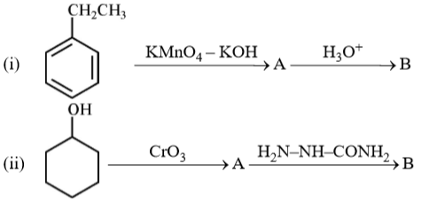

1. (a) How do you convert the following :

(i) Phenol to Anisole (ii) Ethanol to Propan-2-ol

(b) Write mechanism of the following reaction:

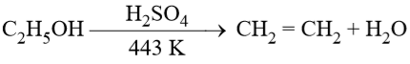

(c) Why phenol undergoes electrophilic substitution more easily than benzene?

(d) Account for the following:

(i) o-nitrophenol is more steam volatile than p-nitrophenol.

(ii) t-butyl chloride on heating with sodium methoxide gives 2-methylpropene instead of t-butylmethylether.

1. (a) Write the reaction involved in the following:

(i) Reimer-Tiemann reaction (ii) Friedal-Crafts Alkylation of Phenol

(b) Give simple chemical test to distinguish between Ethanol and Phenol.

1. (a) Give equations of the following reactions: (i) Phenol is treated with conc. HNO3. (ii) Propene is treated with B2H6 followed by H2O2/OH–.

(iii) Sodium t-butoxide is treated with CH3Cl.

(b) How will you distinguish between butan-1-ol and butan-2-ol?

(c) Arrange the following in increasing order of acidity: Phenol, ethanol, water

1. (a) How can you obtain Phenol from (i) Cumene, (ii) Benzene sulphonic acid, (iii) Benzene diazonium chloride?

(b) Write the structure of the major product obtained from dinitration of 3-methylphenol. (c) Write the reaction involved in Kolbe’s reaction.

1. An aromatic compound ‘A’ on treatment with CHC*l*3 and KOH gives two compounds, both of which give same product ‘B’ when distilled with Zinc dust. Oxidation of ‘B’ gives ‘C’ with molecular formula C7H6O2. Sodium salt of ‘C’ on heating with soda lime gives ‘D’ which may also be obtained by distilling ‘A’ with Zinc dust. Identify ‘A’, ‘B’, ‘C’ and ‘D’.
2. How do you convert the following: (a) Phenol to Toluene (b) Ethanol to Ethanal?
3. Give one chemical test to distinguish between the following : (a) Phenol and 1-propanol (b) Ethanol and dimethyl ether (c) 1-propanol and 2-Methyl-2-propanol.

**…………………….**